**CHAPTER 1**

**PROJECT DEFINITION**

* 1. **INTRODUCTION**

The Furniture Shop now stands on it’s 36th year with two stores found in Bacoor and Silang, Cavite. The shop offers high quality furniture that goes from simple and classic to one very luxurious design.

The business is owned and managed by a family, but mostly by the parents who still list and writes the orders made per day and the receipts and bill per transaction. It’s difficult processing the transaction due to unorganized stack of charts and voluminous brochures. The shop also uses the forms improperly which leads to difficult retrieval of order records.

The proponents aim to provide a Web-Based Management system entitled, Furniture Shop Management System. This system will help the family in making faster transactions.

It will help them in storing and retrieving information, enhancing the security of their records. The customers will also find it more convenient to choose a furniture by sending their desired design with the customization feature. With this system, the furniture shop that is running for 36 years now, will keep up with the rapidly changing society and developing technology.

* 1. **BUSINESS CASE**
     1. **BACKGROUND OF THE ORGANIZATION**

The Furniture Shop makes high quality furniture made of narra wood with designs that goes from simple and classic to a very luxurious one. They offer furniture generously made of narra and of high quality fabrics imported from other countries. The shop creates furniture for display and for walk-in customers to see and purchase. They accept orders with designs picked from their brochures or customized designs specified or brought by the customer.

The 36 year old running business now has two stores; both stores are managed by the family members themselves. Josephine Bonayon Baraquiel, one of the owners, proposed the idea of making furniture shop to her husband because she herself is a daughter of a furniture maker. Josephine used to help her parents way back when she was in their care, her parents influenced her in every way and together with her husband they build the Furniture shop together.

This business is the reason they got to where they are now, from a small shop at vicinity in Albay, Bicol to owning two stores located nearby the capital city of the country. The Furniture Shop is also the reason how they manage to send their six children to decent universities and now their children are working at great companies and is helping them from time to time.

The Furniture shop’s number one priority in furniture making is ensuring that the furniture they make is of high quality and can be considered world class. They also wanted to join the bandwagon of online shops in the country to be part of this rapidly changing society.

* + 1. **PROJECT OVERVIEW**

The project aims to help the said Furniture Shop in making their transactions faster, easier and help them keep pace with the rapidly changing society by providing them a web-based system. This web-based system will have a website and an admin interface. The admin interface is where the manager can update their featured furniture, add and remove furniture and manage orders made personally or through the website. The website will display all furniture the shop can offer. The customer can easily order furniture just by browsing through the website and the manager will find it easy to manage orders and produce the customers’ bills and receipts.

It will also help the customers choose design on their perspective by sending their own design in our customization feature. With the system the manager can easily store and retrieve information, thus minimizing the time for looking upon the client’s record every time they deliver.

* + 1. **PROJECT CONSTRAINTS**

The constraints considered by the proponents are the following:

* Time frame given for the project is 10 months, limited amount of time to build the system.
* The scope of the project covers maintainance and transaction processes of the business.
* The proponents are currently students with limited source of income. It is certain that they cannot invest financially.

.

* + 1. **PROJECT ASSUMPTIONS**
* **The Project will be finished on time**

The fully-functional system project will be finished on time with no errors and bugs.

* **The project team will able to acquire all the information and documents needed**

The client will be able to provide all necessary documents and information for the Project Team to comply with the requirements of the project and be able to provide them a running system that functions accurately.

* **User Acceptance**

The client will be satisfied with the final outcome of the project. The project will lighten the works of the users, their transaction will be faster and provide a better service to their customers.

**1.3. SCOPE AND LIMITATION**

The business processes of the furniture shop includes managing of orders, create billing and collections and production tracking.

Transaction includes point of sales, raw materials management, delivery tracking and production management. The system will also have a feature of customization which allows the customers to send their own design of the furniture. Maintenance of the fields needed for the transactions will be covered. The system also produces queries and reports.

The system will not cover the purchasing of orders in monitoring the inventory of raw materials.

**1.4. METHODS USED IN THE STUDY**

**1.4.1 Data Gathering Techniques**

* **Observation**

The proponents observed the business environment and how they do things thus making it easier for us to know their problems.

* **Personal Interview**

The proponents conducted an interview to gather data needed for this project. This serves as the way to obtain useful information to the people who know the business very well.

* **Document Analysis**

The forms we gathered will be analyzed to understand the business and know what data are needed for the transactions.

**1.4.2 Software Process Model**

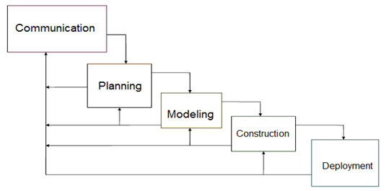

***Figure 1.1 Waterfall Model with Feedback***

The proponents used the Waterfall Model with Feedback as a model used in visualizing the step by step process the group is going to take to finish the project on the scheduled time. The Waterfall Model with Feedback is a simple and easy to use model because of it’s rigidity. Each phases has a specific deliverable and a review process therefore after making progress on the project we can go back to the client and ask if what we produce is accurate according to their business rules and processes.

**CHAPTER 2**

**FUNCTIONAL SPECIFICATION REPORT**

**2.1 DATA REQUIREMENTS**

**2.1.1 FORMS**

**2.1.1.1 LIST OF FORMS**

|  |  |  |  |
| --- | --- | --- | --- |
| **Form #** | **Form Name** | **Description** | **User** |
| F1 | Sales Invoice | This contains the customer information, order information, order specification and payment information. This serves as the contract and the bill. | Manager, Customer |
| F2 | Job Order | This contains the details of the ordered furniture the manufacturer should follow. | Manager, Manufacturer |
| F3 | Delivery Receipt | It contains delivery information, order information and payment information. This is given to the delivery man and later on passed to the customer as final receipt. | Manager, Customer, Delivery Man, |
| F4 | Official Receipt | This contains the payment details of the customer. This is given to the customer every payment made. | Manager, Customer |

***Table 2.1 List of Forms***

**2.1.1.2 SAMPLE OF FORMS**

**SALES INVOICE**

**Sold to**: Rosario Hernandez **DATE:** December 12, 2016

**Address:** Baco**or,** Cavite  **CONTACT NO.:** 09163737052

|  |  |  |
| --- | --- | --- |
| QUANTITY | PARTICULAR ITEM | AMOUNT |
| 1 SALA SET | MANILENIA  FABRIC GOLD RANI  COLOR 19C  1 PC. LOVE SEAT  1 PC. CENTER TABLE  2 PCS SIDE TABLE  1 SET DINING SET | TOTAL AMOUNT  170,000   * 100,100   BALANCE 70,000 |

RECEIVED BY: JOSEPHINE BARAQUEL

SIGNATURE OVER PRINTED NAME

***Figure 2.1 Sample Sales Invoice Format***

**SI #123 ROSARIO HERNANDEZ**

1 SET SALA SET – MANILENIA

FABIC: GOLD RANI

COLOR: 19C

1 PC. LOVE SEAT

1 PC CENTER TABLE 22 X 42’

2 PCS SIDE TABLE 18 X 22”

1 SET DINING SET W/ 8 CHAIRS

***Figure 2.2 Sample Job Order Format***

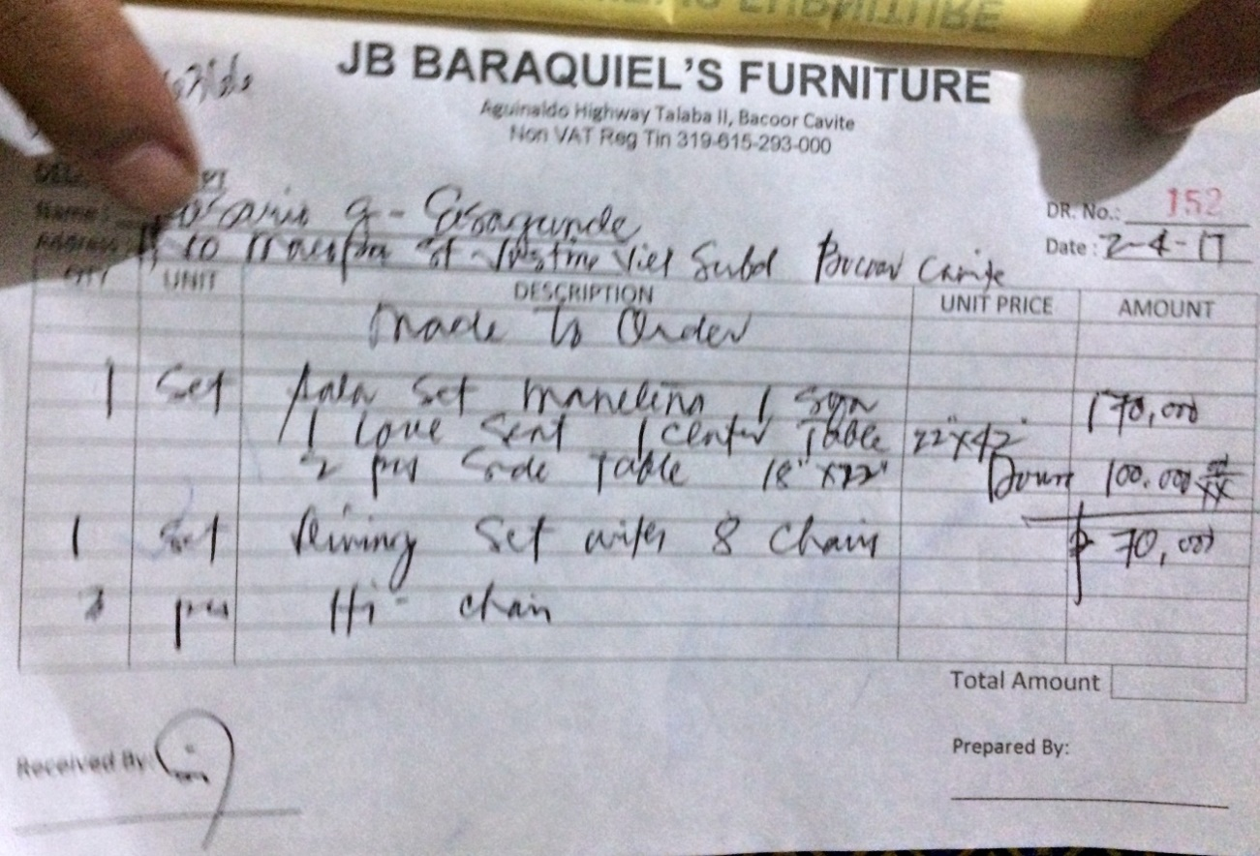

***Figure 2.3 Sample Delivery Receipt***

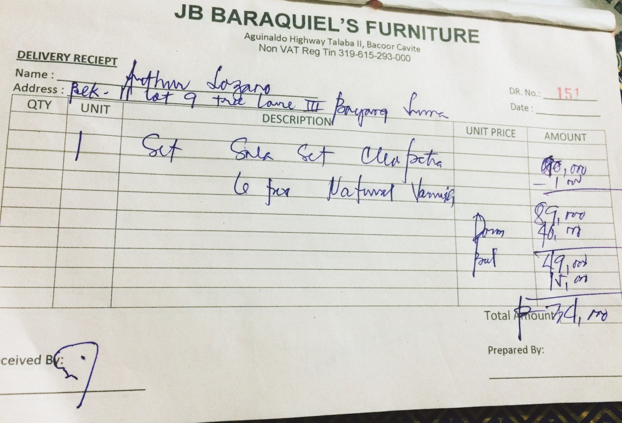

***Figure 2.3.1 Sample Delivery Receipt***

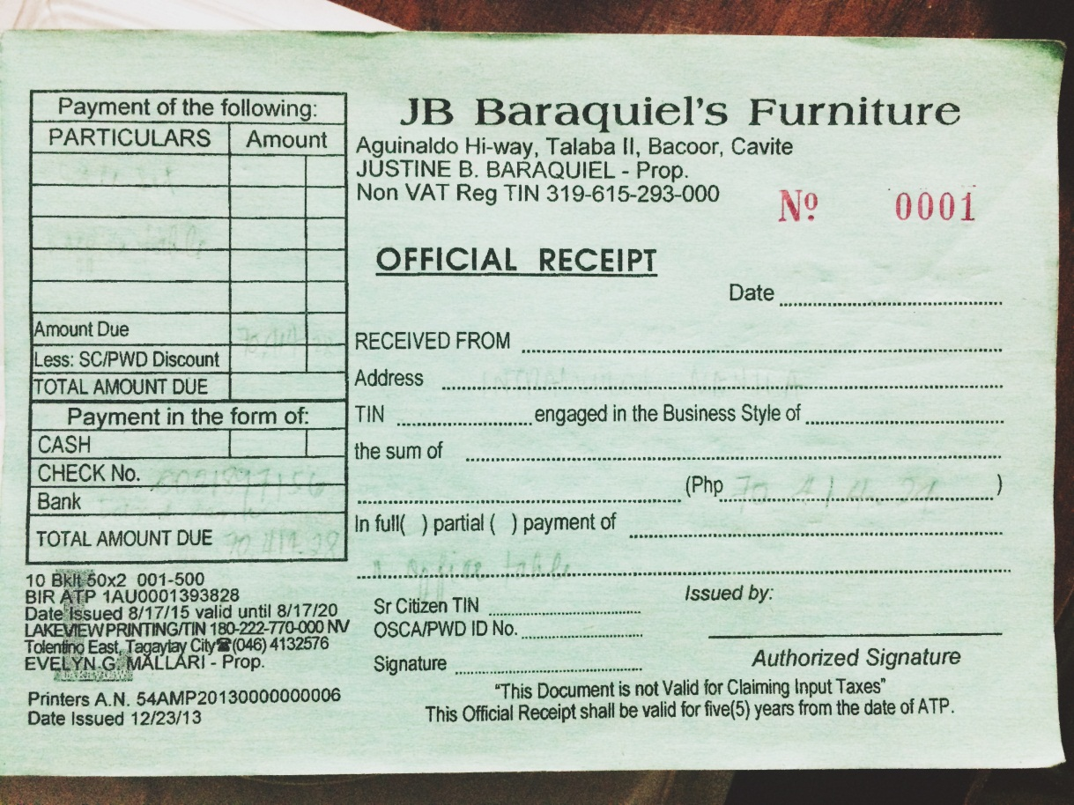

***Figure 2.4 Sample Official Receipt***

**2.1.2 REPORTS**

**2.1.2.1 LIST OF REPORTS**

|  |  |  |  |
| --- | --- | --- | --- |
| **Report #** | **Report Name** | **Description** | **Frequency** |
| R1 | Sales Report | Contains the daily record of the furniture sold to customers. | Daily, Monthly, Annually |

***Table 2.2 List of Reports***

**2.1.2.2 SAMPLE REPORTS**

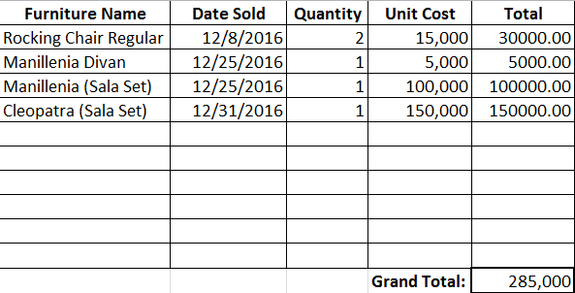

***Figure 2.5 Sample Sales Report Format***

**2.2 POLICIES AND PROCEDURES**

**2.2.1 PROCEDURES**

**2.2.1.1 CONTEXT DIAGRAM**

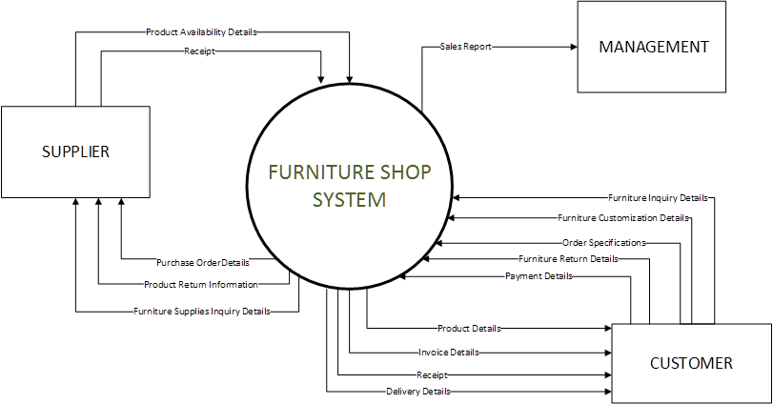

***Figure 2.6 Context Diagram***

**2.2.1.2 LEVEL 1 DFD**

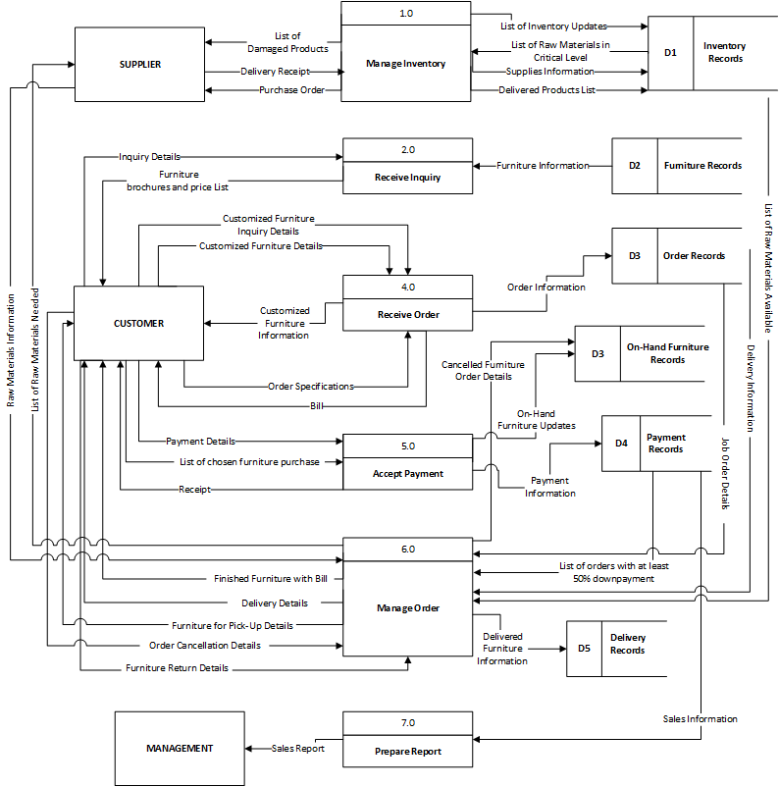

***Figure 2.7 Level 1 Data Flow Diagram***

**2.2.2 POLICIES**

**2.2.2.1 BUSINESS REQUIREMENTS**

|  |  |
| --- | --- |
| **BR NO.** | **BUSINESS REQUIREMENT** |
| **BR001** | The production of furniture will begin once the customer paid a down payment of at least 50% of the total amount of the ordered furniture. |
| **BR002** | A minimum storage fee of PHP 500 pesos will be added to the total balance if furniture is not claimed or is fully paid on or before the day the contract will end. |
| **BR003** | A detailed description and specification is needed for customized furniture. |
| **BR004** | Damage on furniture caused by natural disaster and by improper use or maintenance is not covered on the warranty. |
| **BR006** | Official receipt must be presented to acquire warranty. |
| **BR007** | A minimum fee of PHP 500 is needed to cancel an order that is already undergoing production. |

***Table 2.3 Business Requirement***

**2.2.2.2 BUSINESS POLICIES**

|  |  |
| --- | --- |
| **BP NO.** | **BUSINESS POLICIES** |
| **BP01** | The customer must pay at least 50% of the total price of the furniture ordered for the production of furniture to begin. |
| **BP02** | On-hand furniture must be fully paid upon acquisition. |
| **BP03** | Furniture must be claimed, paid or delivered on or before the end of the contract. |
| **BP04** | A customer must pay a cancellation fee if he/she cancels his order that is already undergoing production. Cancellation fee varies. |
| **BP05** | If ordered furniture is not claimed and fully paid within 1 month (30 days) and 1 week after the contract’s expiration the management has the right to resell the furniture. |
| **BP06** | The price of a customized furniture will be decided by the management |
| **BP07** | The furniture will be replaced or repaired if found broken upon delivery. |
| **BP08** | Six months warranty is given to all furniture. |

***Table 2.4 Business Policies***

**2.3 PROBLEM ANALYSIS**

**2.3.1 FISHBONE**

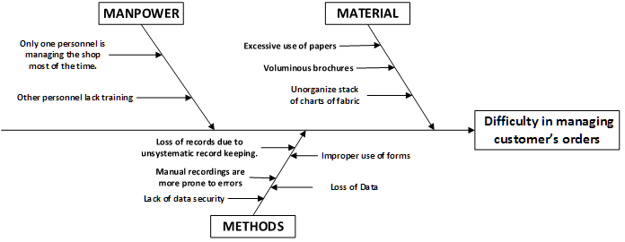

***Figure 2.8 Fishbone Diagram of the Furniture Shop***

**2.3.2 PROBLEMS AND REQUIREMENTS**

|  |  |  |  |
| --- | --- | --- | --- |
| **Ref. Page** | **No.** | **Problem** | **Requirements** |
| 16 | 1 | Only one personnel is managing the shop most of the time. | Capability to efficiently manage orders with the resource available. |
| 16 | 2 | Loss of records due to unsystematic record keeping. | Secure records in a database to manage systematically. |
| 16 | 3 | Lack of data security. | Ability to keep the gathered data and control the user access. |
| 16 | 4 | Excessive use of papers. | Capability to minimize,if not eliminate the use of paper. |
| 16 | 5 | Voluminous brochures. | Provides categorized products for display. |
| 16 | 6 | Improper use of forms. | Capability to identify the form/s to be used in the given transactions. |
| 16 | 7 | Loss of data. | Ability to keep data for every transactions made. |

***Table 2.5 Problems and Requirements***

**2.3.3 CONCLUSIONS**

The Furniture Shop offers high quality furniture made of narra wood. They aim to provide high quality furniture that goes from simple and classic to one very luxurious design, not just to citizens of Cavite but as much as possible, to the whole country.

As of now, the said Furniture shop uses the manual process of recording data, the manager will write the customer information, order information, billing information, and they allow the client to customize their own designs of furniture. A lot of data is being stored so the shop uses excessive papers, papers that are being stored on the file cabinets around their small office. They also use their forms improperly providing confusing records that leads to difficulty in managing customer’s orders.

**2.3.3 RECOMMENDATIONS**

In order to help the business resolve the problems stated above, the proponents recommend the Furniture Shop to have a Web-Based system that will help them manage order and the information that is going in and out of the shop, at the same time will help them promote their products and reach customers on a farther vicinity. The Filipiniana Furniture Shop Management System will have the following sub-systems:

The Furniture Ordering Management System, this sub-system will help the manager in managing the orders. The customer will be able to order furniture easily. Additionally, this sub-system also has a customization feature where the customer can customize furniture to their own liking. In this sub-system, all on-hand furniture and furniture available for pre-order will be displayed per category for the customer to easily choose. Once, the customer is done ordering he can just check-out and proceed to billing. The customer information will be needed for verification.

The Billing and Collection System, this sub-system will compute the total amount of furniture in the customer’s orders. After checking-out the customer will receive an email from the furniture shop containing his bill and where and how the customer can pay. If the ordered furniture is on-hand and the customer has paid for it the furniture will be delivered. If it’s pre-order, the production of the ordered furniture will begin once the customer has paid 50% of the total amount. However, the order will be considered null and void if the customer fails to pay within seven days. This sub-system will help in producing receipt easily, lessening the time needed for writing.

The Production Tracking System, this sub-system will track the production of an order. After the transaction is settled, the manager will issue job order form for the manufacturers, this job order form contains the specifications and descriptions of the furniture to be made. This sub-system will enable the manager to view and update production progress information, which includes status of the production, the handler who will make the furniture, and the production progress percentage of the furniture.

**CHAPTER 3**

**PROPOSED SYSTEM DEFINITION**

**3.1 Requirements-Features Matrix**

|  |  |  |  |  |  |  |  |
| --- | --- | --- | --- | --- | --- | --- | --- |
| **Features/ Requirements** | **REQ1.**  *Capability to efficiently manage orders with the resource available.* | **REQ2.**  *Secure records in a database to manage systematically..* | **REQ3.**  *Ability to keep the gathered data and control the user access.* | **REQ4.**  *Capability to minimize, if not eliminate the use of paper.* | **REQ5.** *Provides categorized products for display.* | **REQ6.**  *Capability to identify the form/s to be used in the given transactions* | **REQ7.**  *Ability to keep data for every transactions made.* |
| **FEAT1.** *Web-based ordering transaction* | **✔** | **✔** | **✔** | **✔** | **✔** | **✔** | **✔** |
| **FEAT2.**  *Tracking of production.* | **✔** | **✔** | **✔** | **✔** |  | **✔** | **✔** |
| **FEAT3.**  *Tracking of delivery.* | **✔** | **✔** | **✔** | **✔** |  | **✔** | **✔** |
| **FEAT4.**  *Inventory of Raw Materials.* | **✔** | **✔** | **✔** | **✔** |  |  | **✔** |
| **FEAT5.** *Customiza-*  *tion of designs.* | **✔** | **✔** |  | **✔** | **✔** | **✔** | **✔** |
| **FEAT6.**  *Ability to produce reports.* |  | **✔** | **✔** | **✔** |  |  | **✔** |

***Table 3.1 Feature-Requirements Matrix***

**3.2 Functional Specification**

**3.2.1 System Boundaries**

**3.2.2 System Use Case Diagram**

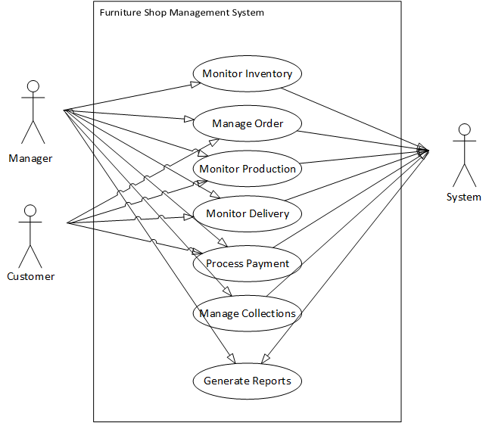

***Figure 3.1 Top level Use case***

**3.2.3 Detailed per Use Case**

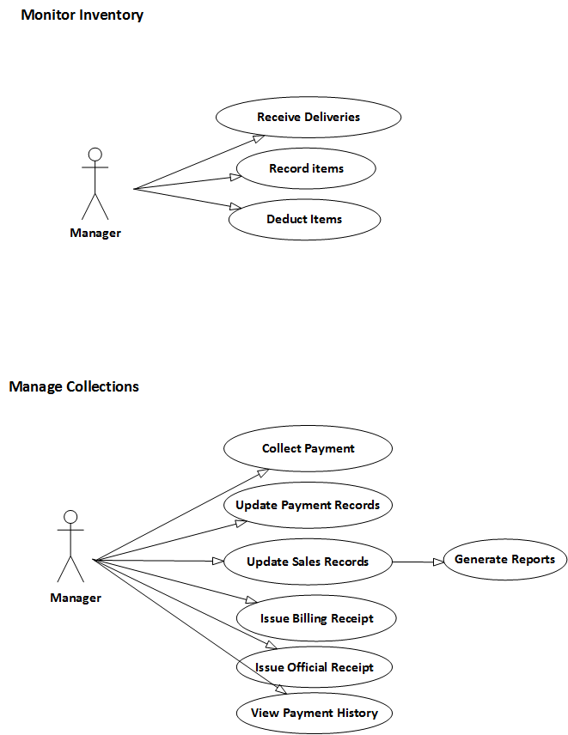

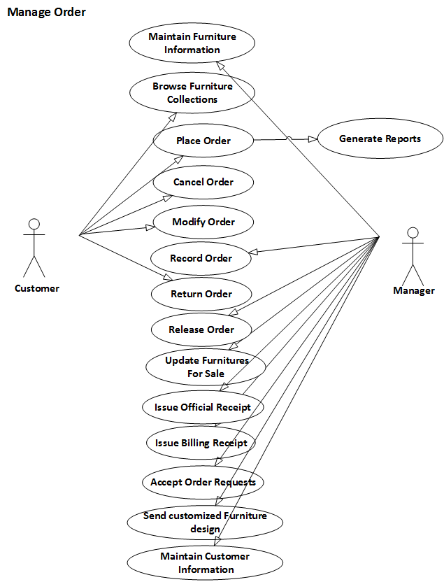

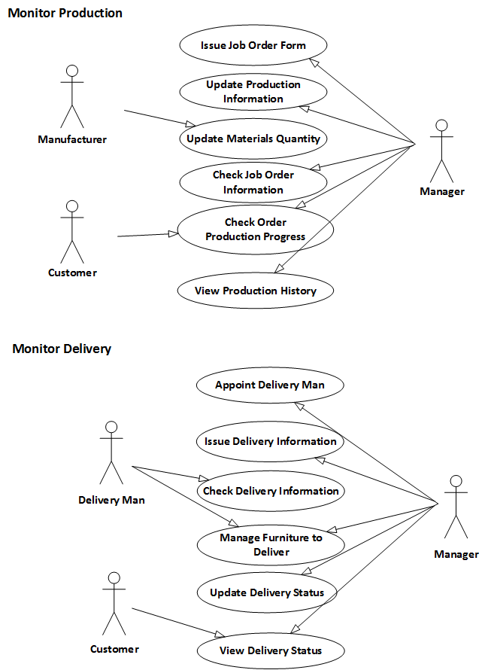

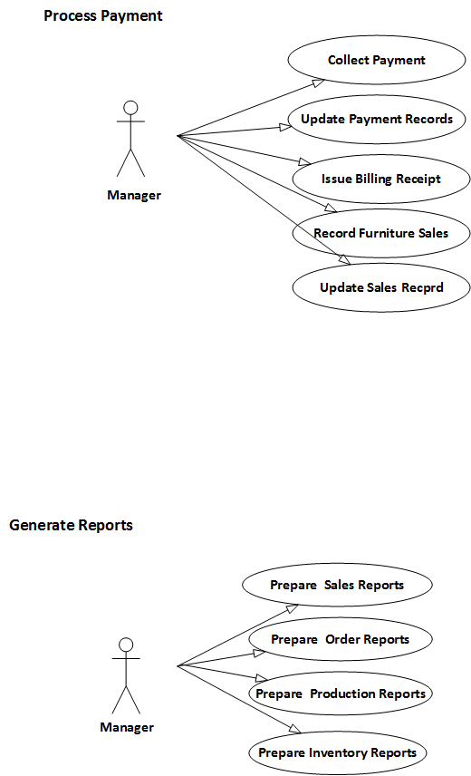





‘

**3.3.4 Use Case Description**

Use case: **Monitor Inventory**

Actor/s: Manager

Purpose: This use case enables the management to record the raw materials they have used for their production.

Brief Description: Monitoring of the inventory of raw materials used in the business.

Pre-condition: Must be an authenticated user.

Post-condition: An item must be deducted or restocked.

|  |  |  |
| --- | --- | --- |
| **BASIC FLOW** | | |
| ACTION EVENT | | SYSTEM RESPONSE |
| **Receive Deliveries** | | |
| 1. Admin accesses Raw Materials Management. | | 1. Displays all materials' status and materials' information. |
| 1. Click Receive Deliveries Button | | 1. Displays Delivery Information from the suppliers. |
| 1. Enables admin to accept a delivery from the supplier. Adding the raw materials to the raw materials storage. |
| **Record Items** | | |
| 1. Click Restock button | 1. Enables user to update the quantity of a certain item. | |
| **Deduct Items** | | |
| 1. Click Deduct button | | 1. Allows user to deduct the quantity of a certain item. |

Use case: **Manage Orders**

Actor/s: Manager/Customer

Purpose: Allows the management and the customer to keep the transacted orders made in the business.

Brief Description:This use case is capable of processing the main function of the business.

Pre-condition: Must be an authenticated user.

Post-condition: An order must be saved.

|  |  |
| --- | --- |
| **BASIC FLOW:** | |
| ACTION EVENT | SYSTEM RESPONSE |
| **Maintain Furniture Information** | |
| 1. Admin accesses products. | 1. Displays furniture details. |
| 1. Click update button. | 1. Enables admin to edit furniture information. |
| 1. Click Save button | 1. Save information to database. |
| 1. Click View button | 1. Allows user to see the information of a certain furniture. |
| 1. Click Deactivate button | 1. Deactivates the existence of a furniture. |
| **Browse Furniture Collections** | |
| 1. Admin accesses Order Management | 1. Displays the products being sold. |
| 1. Click view button. | 1. Displays all the information about a particular product. |
| **Place Order** | |
| 1. Admin or Customer accesses products. | 2. Displays the products being sold. |
| 3. Click cart button. | 4. Add the selected product to cart. |
| 5. Click proceed to checkout button. | 6. Enables user to put information such as the delivery information, payment information, customer information, and remarks about the order information. |
| 7. Click Save & Print | 8. Saves the order to Orders. |
| **Cancel Order** | |
| 1. Admin or Customer accesses orders. | 2. Displays all the user's orders. |
| 3. Click Update button. | 4. Enables the user to modify his orders. |
| 5. Click cancel order button. | 6. Enables the user to cite out the reason for cancelling. |
| 7. Click cancel order button | 8. Deletes the order from Orders. |
| **Modify Order** | |
| 1. Admin or Customer accesses orders. | 2. Displays all the user's orders. |
| 3. Click Update button. | 4. Enables the user to modify his orders. |
| 5. Click Save button | 6. Saves the new order information. |
| **Record Order** | |
| 1. Admin accesses orders. | 2. Displays all the user's orders. |
| 3. Click accept button. | 4. Accepts an order. |
| **Return Order** | |
| 1. Admin click Return orders from transaction. | 1. Display list of return orders and its status. |
| 1. Click Update button | 1. Enables user to update the status of the returned product. |
| **Release Order** | |
| 1. Admin accesses Releasing of orders in transaction. | 1. List of orders to be delivered must be displayed. |
| 1. Click New button | 1. Enables user to modify an order to be released. |
| 1. Click Delivery Receipt | 1. Must output a receipt to be printed. |
| **Update Furniture Sales** | |
| 1. Admin accesses orders. | 1. Displays all the furnitures for sale. |
| 1. Click Update button. | 1. Enables the admin to modify furniture information. |
| 1. Click Save button | 1. Saves the updated furniture information. |
| **Issue Billing Receipt** | |
| 1. Admin access Orders | 1. List of orders withing bills must be displayed. |
| 1. Click Bill button | 1. Billing receipt must be produced |
| **Issue Official Receipt** | |
| 1. Admin access Ordering in transactions | 1. Enables user to order from brochures displayed. |
| 1. Click save button | 1. Saves information to the database. |
| 1. Click Print button | 1. Official receipt must be produced. |
| **Accept Order Requests** | |
| 1. Click Order Request from Orders | 1. Displays list of order requests from the website. |
| 1. Click Accept button | 1. Accepts the order requests and transfer to Orders. |
| **Send Customized Furniture Design** | |
| 1. Admin access Dashboard. |  |
| 1. Click Customization Request | 1. List of customer request must be displayed. |
| 1. Click Accept | 1. Accepts the request made by the customer. |
| **Maintain Customer Information** | |
| 1. Admin access Customer information tab. | 1. Displays list of customers’ information that can be modified. |

Use case: **Monitor Production**

Actor/s: Manager/Customer

Purpose: Enables the management and the customer to track the production made per order.

Brief Description: Monitoring of the production per furniture ordered.

Pre-condition: Must be an authenticated user.

Post-condition: A production must be updated per phase finished.

|  |  |  |  |  |  |
| --- | --- | --- | --- | --- | --- |
| **BASIC FLOW** | | | | | |
| ACTION EVENT | SYSTEM RESPONSE | | | | |
| **Issue Job Order Form** | | | | | |
| 1. Click ‘Update’ on any production phase displayed. | 1. Enables the user to update Production Information of furniture depending on what phase the production has gone to. | | | | |
|  | 1. Display’s list of materials needed. | | | | |
| 1. Click ‘Print Job Order’ | 1. Job Order Form must be issued | | | | |
| **Update Production Information** | | | | | |
| 1. Admin accesses Production Tracking in Transactions. | 1. Orders that are undergoing or pending for production is displayed. | | | | |
| 1. Click View Details | 1. Display the ordered furniture and it’s production details. | | | | |
| 1. Click ‘Start’ on any production phase displayed. | 1. Display the materials needed and the form for saving the information of when the production started and who handles that phase of production | | | | |
| 1. Click ‘Update’ on any production phase displayed. | 1. Enables the user to update Production Information of furniture depending on what phase the production has gone to. | | | | |
| **Update Materials Quantity** | | | | | |
| 1. Click an on-going production | | 1. Displays information about the production. | | | |
|  | | 1. Enables user to deduct or add a material quantity per phase. | | | |
| **Check job order information** | | | | | |
| 1. Click an order production finished. | | | 1. Job order must be produced. | | |
| **Check production Progress** | | | | | |
| 1. Click Production Tracking | | | | 1. Displays list of production and its information. | |
| **View Production History** | | | | | |
| 1. Click any order production icon. | | | | | 1. Displays progress for each phase. |
| 1. Click production history button. | | | | | 1. Displays Production History. |

Use case: **Monitor Delivery**

Actor/s: Manager/Customer

Purpose: Enables the management and the customer to track the delivery made per order.

Brief Description: Monitoring of the delivery for every order made.

Pre-condition: Order must be finished and paid.

Post-condition: Delivery information must be updated.

|  |  |  |  |
| --- | --- | --- | --- |
| **BASIC FLOW** | | | |
| ACTION EVENT | | SYSTEM RESPONSE | |
| **Appoint Delivery Man** | | | |
| * 1. Click ‘Update’ on any production phase displayed. | | * 1. Enables the user to update Production Information of furniture depending on what phase the production has gone to. | |
|  | | * 1. Display’s list of materials needed. | |
| * 1. Click ‘Print Job Order’ | | * 1. Job Order Form must be issued | |
| **Issue Delivery Information** | | | |
| 1. Admin click the ‘Releasing of Order’ under Order Management | | 1. Displays Delivery information per order. | |
| **Check Delivery Information** | | | |
| 1. User clicks ‘Releasing of Orders’ under Order Management | 1. Displays Order’s information and status. | | |
| **Manage Furniture to Deliver** | | | |
| 1. Click New button | 1. Displays form about the order and delivery details to be fill up by the user. | | |
| 1. Choose order number or name to whom the delivery will address. | 1. Displays orders to be delivered. | | |
|  | 1. Release information to be fill up by the user must display. | | |
| **Update Delivery Status** | | | |
| 1. Click an order to be updated. | | 1. Shows form that must be fill up by the user to be able to update a delivery status. | |
| 1. Click the check box for finish delivery. | | 1. Date to be modified must appear. | |
| 1. Click Save button | | 1. Delivery status must change depending on the updated information inputted. | |
| **View Delivery Status** | | | |
| 1. User clicks ‘Releasing of Orders’ under Order Management | | | 1. Displays Order’s information and delivery status. |

Use case: **Process Payment**

Actor/s: Manager

Purpose: Record every process made per payment transacted in the business.

Brief Description: Keeps the information needed for every payment made by the customer to the Furniture shop.

Pre-condition: An order must be made.

Post-condition: Official Receipt and Billing is produced.

|  |  |  |  |
| --- | --- | --- | --- |
| **BASIC FLOW** | | | |
| ACTION EVENT | SYSTEM RESPONSE | | |
| **Collect Payment** | | | |
| 1. Admin inputted the payment details from the customer. | | 1. Computes change for the remaining balance. | |
| 1. User clicks Save button | | 1. Official Receipt must be produced. | |
|  | | 1. Official Receipt should be printed. | |
| **Issue Billing Receipt** | | | |
| 1. Click Bill button from the Collections transaction. | | | 1. Billing receipt is produced. |

Use case: **Manage Collections**

Actor/s: Manager

Purpose: To keep track of the billing payments made by the customers.

Brief Description: Manage payments made from billing transactions per every product sold.

Pre-condition: Successful order record must be existing.

Post-condition: Official and Billing receipt is produced.

|  |  |  |  |
| --- | --- | --- | --- |
| **BASIC FLOW** | | | |
| ACTION EVENT | | | SYSTEM RESPONSE |
| **Collect Payment** | | | |
| 1. Admin inputted the payment details from the customer. | 1. Computes change for the remaining balance. | | |
| 1. User clicks Save button | 1. Official Receipt must be produced. | | |
|  | 1. Official Receipt should be printed. | | |
| **Issue Billing Receipt** | | | |
| 1. Click Bill button from the Collections transaction. | 1. Billing receipt is produced. | | |
| **Issue Official Receipt** | | | |
| 1. Click Payment button | |  | |
| 1. Fill up Payment form and input the amount paid. | |  | |
| 1. Click Save button | | 1. Official receipt must be produced and ready to be printed. | |
| **View Payment History** | | | |
| 1. Click ‘Payment’ button. | | 1. Displays payment transaction to be fill up. | |
| 1. Click ‘View Payment History’ button | | 1. Customer’s past records of payments is displayed. | |

Use case: **Generate Reports**

Actor/s: Manager

Purpose: To keep track of the records gathered from the transactions made by the business.

Brief Description: Official documents that gives summarized information about a particular transaction.

Pre-condition: There must be a daily/monthly/annually data from the records.

Post-condition: Reports for a particular transaction is produced.

|  |  |  |
| --- | --- | --- |
| **BASIC FLOW** | | |
| ACTION EVENT | SYSTEM RESPONSE | |
| **Prepare Sales Report** | | |
| 1. Admin accesses Sales Report in Reports. | 1. Displays list of sales depending on the frequency selected. | |
| 1. Choose daily in frequency | 1. Displays list of sales records within the day. | |
| 1. Choose monthly in frequency | 1. Display list of sales records within the month. | |
| 1. Choose annual in frequency | 1. Display list of sales records within the year. | |
| 1. Click Print button. | 1. Must print sales report of within the chosen frequency. | |
| **Prepare Order Report** | | |
| 1. Admin accesses Order Report in Reports. | 1. Displays list of Order records depending on the frequency selected. | |
| 1. Choose daily in frequency | 1. Displays list of Order records within the day. | |
| 1. Choose monthly in frequency | 1. Display list of Order records within the month. | |
| 1. Choose annual in frequency | 1. Display list of Order records within the year. | |
| 1. Click Print button. | 1. Must print Order report of within the chosen frequency. | |
| **Prepare Production Report** | | |
| 1. Admin accesses Production Report in Reports. | | 1. Displays list of Production records depending on the frequency selected. |
| 1. Choose daily in frequency | | 1. Displays list of Production records within the day. |
| 1. Choose monthly in frequency | | 1. Display list of Production records within the month. |
| 1. Choose annual in frequency | | 1. Display list of Production records within the year. |
| 1. Click Print button. | | 1. Must print Production report of within the chosen frequency. |
| **Prepare Inventory Report** | | |
| 1. Admin accesses Inventory Report in Reports. | | 1. Displays list of Inventory records depending on the frequency selected. |
| 1. Choose daily in frequency | | 1. Displays list of Inventory records within the day. |
| 1. Choose monthly in frequency | | 1. Display list of Inventory records within the month. |
| 1. Choose annual in frequency | | 1. Display list of Inventory records within the year. |
| 1. Click Print button. | | 1. Must print sales report of within the chosen frequency. |

**3.3 Technical Specification**

**3.3.1. Class Diagram**

**3.3.1.1 List of Classes**

|  |  |
| --- | --- |
| Tables | Description |
| tblattribute_measure | Contains the measurements needed for an attribute. |
| tblattributes | Contains the attributes that a material may have. |
| tblbank_accounts | Contains the bank account information provided by the management. If the customer chooses to pay via bank the information of the bank account will be coming from here. |
| tblbranches | Contains the bank account information provided by the management. If the customer chooses to pay via bank the information of the bank account will be coming from here. |
| tblcheck_details | Contains the bank account information provided by the management. If the customer chooses to pay via bank the information of the bank account will be coming from here. |
| tblcompany_info | Table contains the company information. This information is displayed on the website. |
| tblcust_req_images | Contains the images of the customization request from the customer. |
| tblcustomer | Contains the information of the customer. |
| tblcustomize_request | Contains the information of the customer’s customization request. |
| tbldelivery | Contains the delivery information of the order to be delivered. |
| tbldelivery_details | Contains the information of the delivery. |
| tbldelivery_rates | Contains delivery rates information. |
| tbldesign_phase | Contains the phases that a certain furniture design must undergo |
| tbldownpayment |  |
| tblemp_job | Contains the jobs of the employee |
| Tblemployee | Contains the employee information |
| tblfabric_pattern | Contains the patterns or designs of a fabric. It is used to define the fabrics properly. |
| tblfabric_texture | Contains the texture. It is used to define the fabric type properly. |
| tblfabric_type | Contains the fabric types. It is used to define the fabrics properly. |
| tblfabrics | Contains the fabrics. It is used to define the products |
| tblframe_design | Contains the frame design. It is used to define the frameworks. |
| tblframe_material | Contains the frame design. It is used to define the frameworks. |
| tblframeworks | Contains the frameworks. It is used to define the products. |
| tblfurn_category | Contains the category of the products |
| tblfurn_design | Contains the possible design of the product |
| tblfurn_type | Contains the furniture type |
| tblinvoice_details | Table contains the invoice information of the customer’s order |
| tbljobs | Contains the jobs in the company |
| tbllogs | Contains the actions or changes that a certain user did in the system |
| tblmat_actions | Contains the actions done in the raw materials management |
| tblmat_deliveries | Contains the deliveries of materials received from the supplier. |
| tblmat_deliverydetails | Contains the details of the deliveries. |
| tblmat_inventory | Contains the quantity of materials. |
| tblmat_type | Contains the types of material. It is use to define a material. |
| tblmat_var | Contains the variants of a material. |
| tblmaterials | Contains the materials used in making furniture. |
| tblmodeofpayment | Contains the mode of payments. |
| tblonhand | Contains the record of the on hand products. |
| tblorder_actions | Contains the action that the user made on the orders. |
| tblorder_customization | Contains the action customizations or special request the customer has made on every ordered furniture |
| tblorder_request | Contains the details of every order |
| tblorder_return | Contains the record of orders that have been returned |
| tblorder_return_details | Contains the details of the return record |
| tblorders | Contains the orders made by the customers |
| tblpackage_inclusions | Contains the products included in every packages. |
| tblpackage | Contains the packages available in the shop. |
| tblpayment_details | Contains the payments made by the customer |
| tblpenalty | Contains the penalties of the shop |
| tblphases | Contains the phases a furniture must undergo under the production |
| tblprod_images | Contains the other images of the product |
| tblprod_info | Contains the production information of a product according to phase |
| tblprod_materials | Contains the materials needed in every production phase of the product |
| tblprodsonpromo | Contains the materials needed in every production phase of the product |
| tblproduct | Contains the furniture that the shop can make. |
| tblproduction | Contains the production information of every ordered furniture |
| tblproduction_phase | Contains the information of production per phases of production. |
| tblpromo_condition | Contains the condition of a promo |
| tblpromo_promotion | Contains the promotion or the incentive of a promo. |
| tblpromo | This table contains the promos. |
| tblsupplier | This table contains the suppliers |
| tblunit_cat | Contains the category in which the unit of measurement falls. |
| tblunitofmeasure | Contains the unit of measurements |
| tblunitofmeasurement_category | Contains the categories of unit of measurements |
| tbluser | Contains the information of the users of the system. |
| tblvariant_details | Contains the details of the variants |

***Table 3.1 List of Classes***

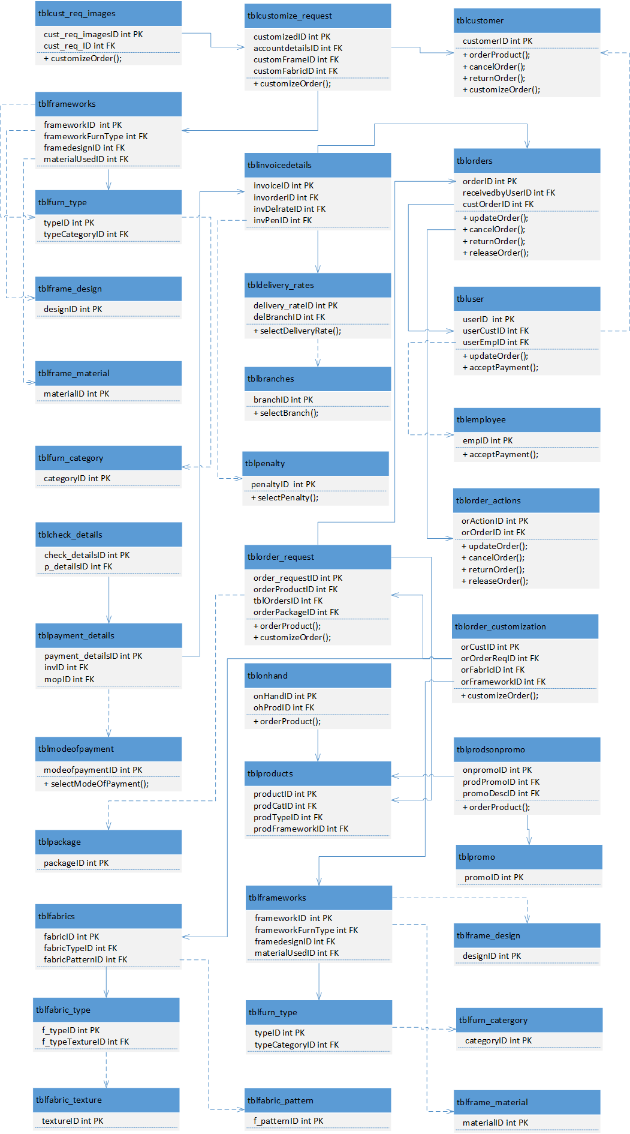**3.3.1.2 Class Diagrams (per Use Case by System)**

***Figure 3.2 Manage Orders Class Diagram***

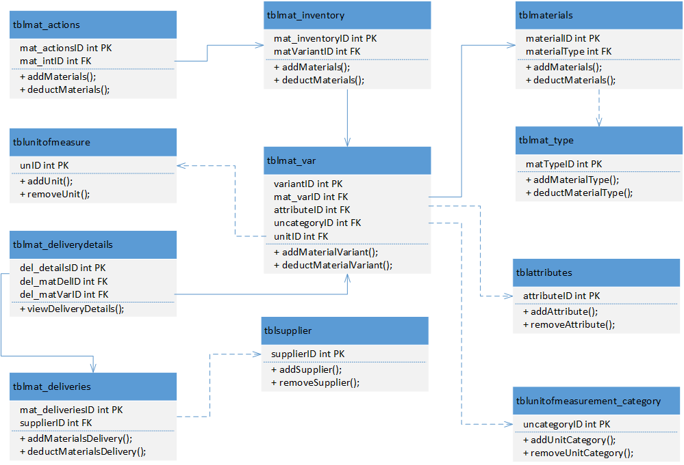

***Figure 3.2.1 Monitor Inventory Class Diagram***

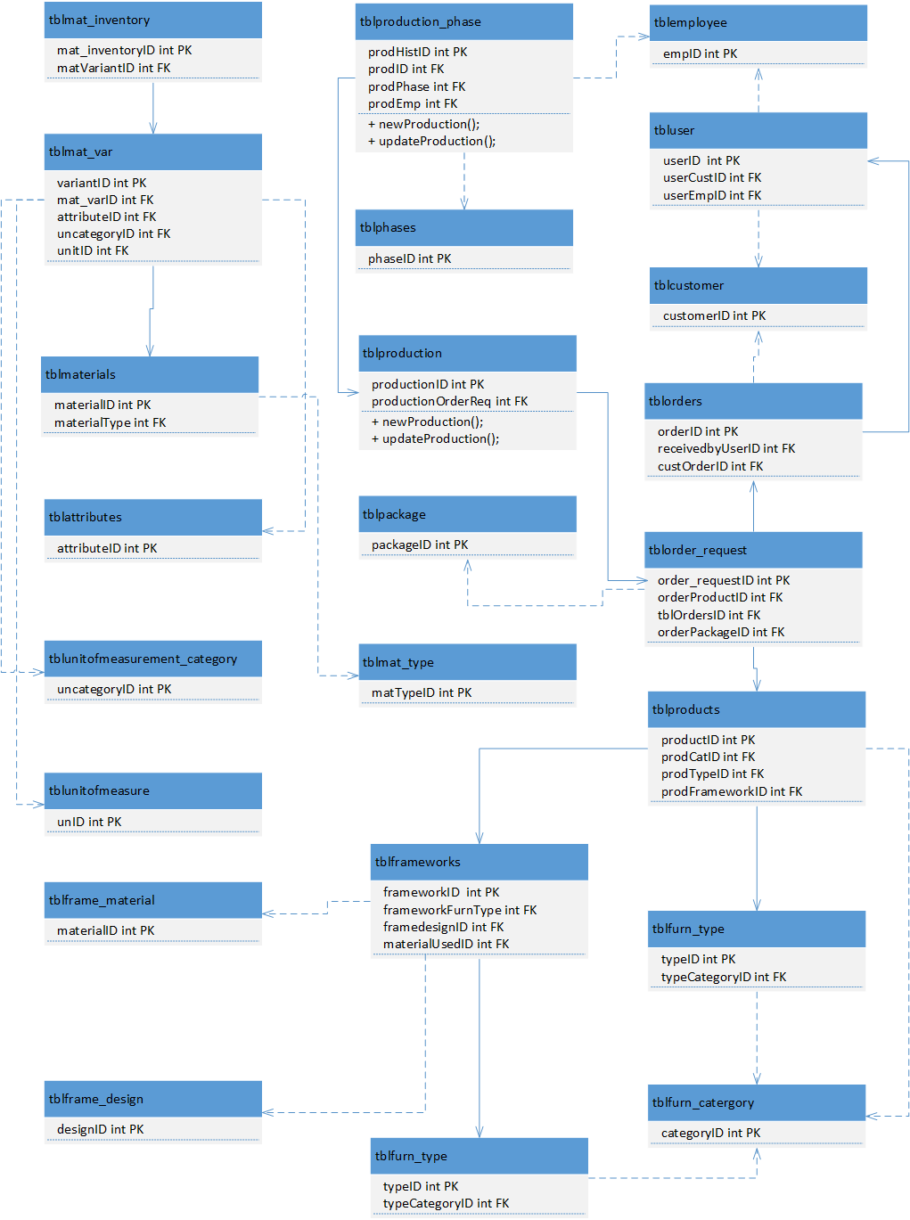

***Figure 3.2.3 Monitor Production Class Diagram***

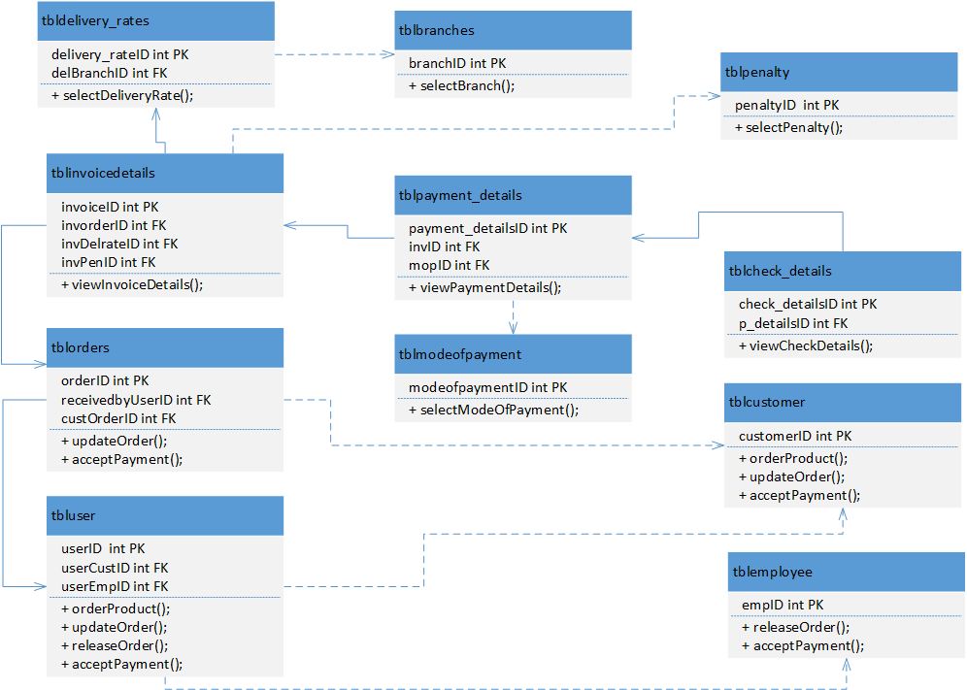***Figure 3.2.4 Process Payment Class Diagram***

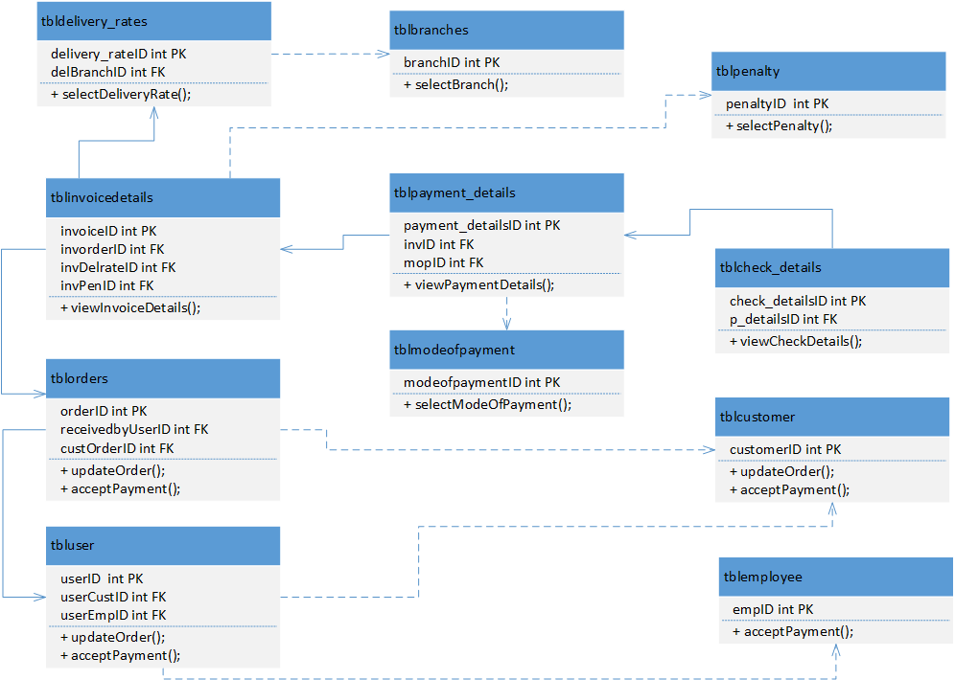

***Figure 3.2.5 Manage Collections Class Diagram***

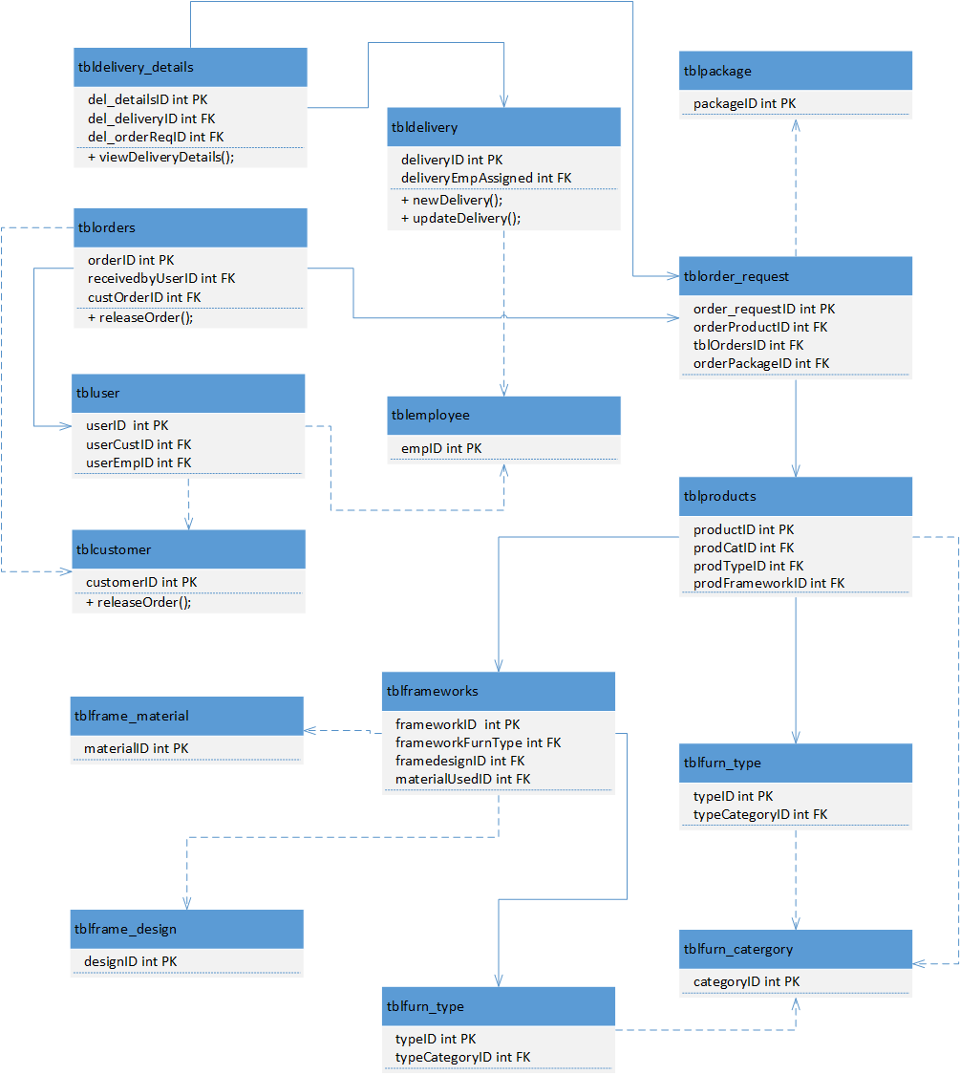

***Figure 3.2.6 Monitor Delivery Class Diagram***

**3.3.2. Activity Diagram**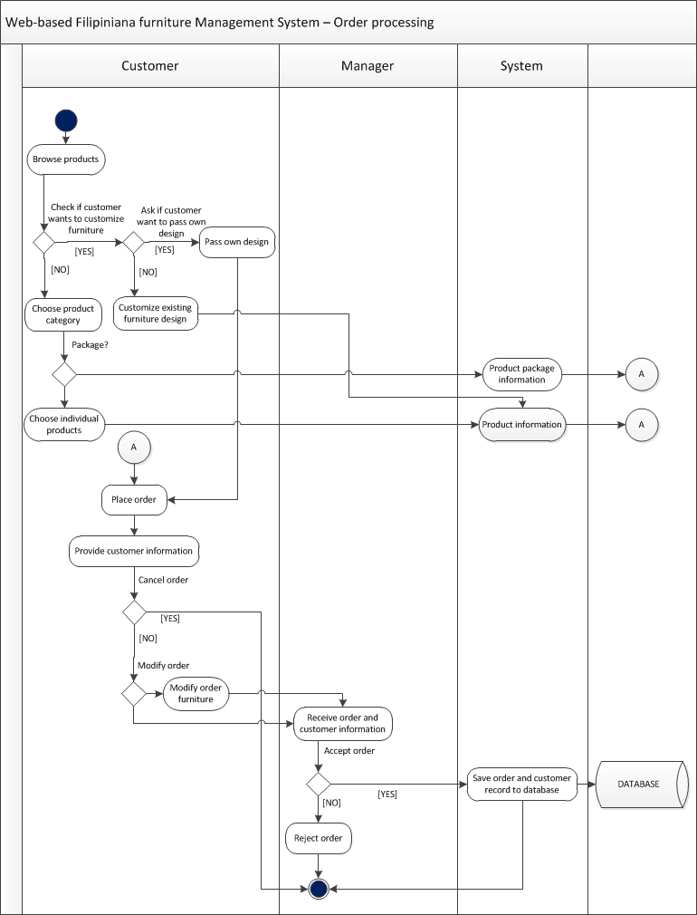

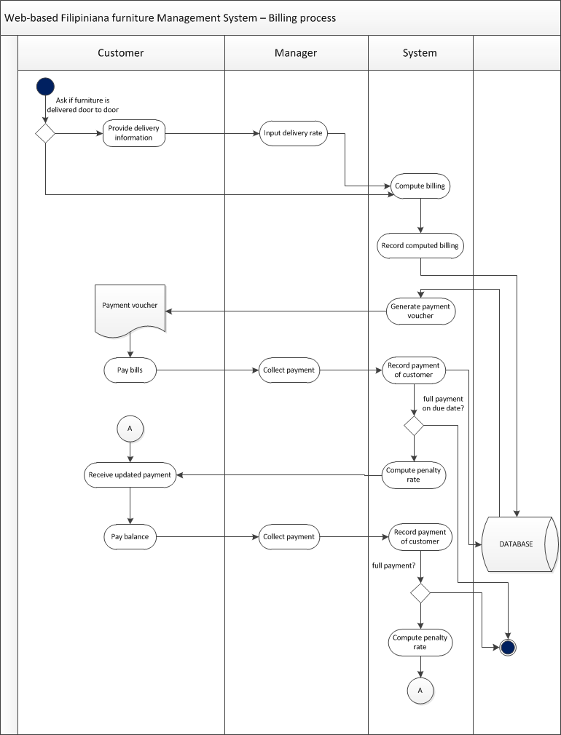





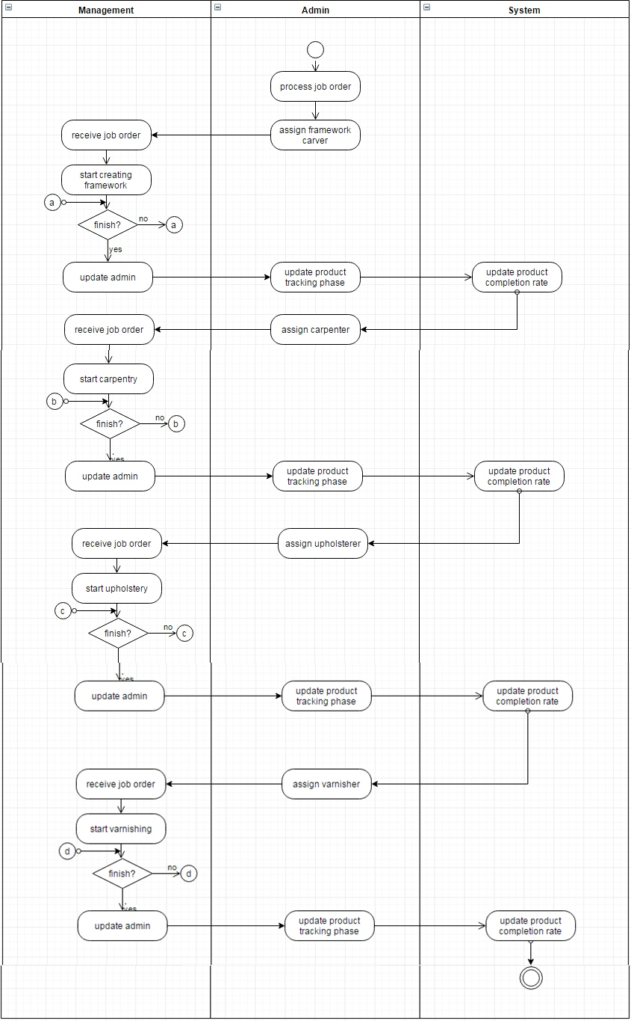Production Tracking

**3.3.3. Database Design**

**3.3.2.1 Database Schema**

